*Journal of Scientific Research and Development (2024) Vol. 23 (1) 77-92*



***A bi-annual journal published by the Faculty of Science, University of Lagos, Nigeria***

*<http://jsrd.unilag.edu.ng/index.php/jsrd>*

Green Innovation: Transforming Carob Pod Shell into Bioplastics with Enhanced Mechanical Strength for Eco-Friendly Application

Ayorinde O. Nejo1\*, Taiwo S. Aiyelero2, Ademola J. Adetona1,3, Lewis O. Gbolaro2

1 Chemistry Department, Faculty of Science, University of Lagos, Nigeria

2 Department of Chemical Science, College of Basic Science, Lagos State University of Science and Technology, Ikorodu, Lagos

3Department of Material Science and Engineering, University of Sheffield, United Kingdom

\*Corresponding Author; [funaina2014@gmail.com](mailto:funaina2014@gmail.com)

*(Received 01 May 2024/Revised 16 October 2024/Accepted 18 October 2024)*

---------------------------------------------------------------------------------------------------------------------

*Abstract*

Plastic's inability to decompose has posed a significant threat to both humans and the environment, necessitating the development of biodegradable polymers. Among these difficulties are greenhouse gas emissions, hazardous chemical leaching, microplastic contamination, and environmental damage. In order to address some of the issues mentioned, this work focuses on the extraction of cellulose from carob pod shells and its subsequent conversion into cellulose acetate and nanocrystals (CNC) for the manufacture of bioplastics. The materials and methods include the isolation of cellulose from biomass through chemical treatments, CNC production through maleic acid hydrolysis, cellulose acetate preparation, and bioplastic synthesis. Evaluations of functional properties, proximate analysis, hemicellulose and lignin content, and % yield were all covered by experimental studies. X-ray diffraction, Fourier Transform Infrared Spectroscopy, and Scanning Electron Microscopywere used in the characterization process. The bioplastic synthesized demonstrated significant degradation of an average mass of 72.13% over a 28 days period, indicating its environmental friendliness. Mechanical properties such as hardness shows that the higher the content of glycerol, the less the hardness; tensile strengthincreased as the amount of glycerol was increased showing a remarkable strength of 8.00 MPa as the minimum(without glycerol) exceeding the minimum value of 1.343 MPa according to the Biodegradable plastic standard SNI 7818:2014; and elongation were also evaluated, showing a positive correlation with the addition of glycerol. XRD and SEM analyses revealed changes in crystallinity and morphology respectively during the bioplastic synthesis process. FT-IR spectra confirmed the chemical modifications, and the degree of substitution for cellulose acetate was determined. The study provides valuable insights into the sustainable utilization of carob pod shell for eco-friendly bioplastic production with desirable mechanical and degradation properties.

Keywords: Carobwaste, Cellulose Acetate, Cellulose Nanocrystals, Bioplastics.

------------------------------------------------------------------------------------------------------------------------------------------

*Introduction*

Cellulose is the most common biopolymer and serves as the main structural component of the cell walls of both higher and lower plants (Feng and You, 2015). It is a polymer composed of subunits of glucose. It is abundant in the cell walls of both bacteria and plants. Stems, stalks, and other woody plant parts have a high cellulose content. Unlike bacteria, which seldom have cellulose in their cell walls, algae and fungus also have it. Similar to higher plants, bacteria that generate acetic acid may also make cellulose. High crystallinity, a high degree of polymerization, high water-absorbing and water-holding capacities, high tensile strength, high elasticity, remarkable biocompatibility, and biodegradability are just a few of the remarkable physicochemical and mechanical properties that cellulose demonstrates (De-france *et al*., 2017). It can be broken down into its glucose components by heating it to high temperatures and exposing it to concentratedinorganic acids. Cellulose is derived from D-glucose units that condense via β 1-4 glycosidic linkages (Morgan, 2018). Individual units of the cellulose chain are linked by strong β 1-4 glycosidic connections, allowing the single cellulose chain to move between both crystalline and disordered domains. The crystalline region of a cellulose fibril has exceptionally aligned cellulose chains (Klemm *et al.*, 2018). Since cellulose fibers have a lot of surface hydroxyl (OH) groups, they may readily establish hydrogen bonds with water molecules, which make it possible for water to spread across the surface. By its very nature, cellulose is an absorbent material that is hydrophilic and hygroscopic.

Lam *et al.* (2012) state that CNCs possess several favourable physical and chemical properties, such as a large number of surface hydroxyl groups, a high stiffness (Young's modulus up to 140 GPa), a high surface area (250 m2/g), and a high tensile strength (7500 MPa). The contemporary world was built with the help of plastics and other common polymers made from fossil feedstocks. Plastic's long durability in both terrestrial and aquatic environments has contributed to ecological degradation, the endangerment of marine life, and health risks for humans (Jiang and Ngai, 2022). Edible packaging films made of organic and biodegradable polymers have been the subject of several investigations. Compared to conventional plastics, biodegradable polymers provide a greater variety of waste management options. The creation of biodegradable materials from renewable natural resources—like plants—has drawn more attention in recent years. This is particularly true in European nations where there has been a resurgence in the utilisation of renewable resources. It is technically and financially feasible to dispose of them in a way that would lessen their environmental impact if handled properly (Rohmawati *et al.*, 2018). In order to create affordable biodegradable and edible films, the polymer matrix and reinforcement should be obtained from abundant and renewable resources. For producing edible films made of starch that have a stronger water vapour barrier and mechanical characteristics, CNCs are an intriguing reinforcement (Rhim *et al.*, 2013). Applications for agglomerated CNCs are limited since they are challenging to disperse physically. To enhance re-dispersion, CNCs can be made more hydrophobic. The hydrophobic alteration of CNC surfaces has drawn a lot of attention since these materials are more suited for usage with water-insoluble polymers like polyolefins (Song and Roja 2013). Due to the considerable polarity difference between hydrophobic and hydrophilic CNCs, it is difficult to thoroughly mix them throughout the reaction process, leading to an inhomogeneous reaction product. Furthermore, there are a number of disadvantages to grafting polymerization for hydrophobic modification, such as constrained reaction conditions, poor grafting efficacy, and complicated grafting homopolymers (Lee *et al.*, 2011; Morandi *et al.*, 2009). Therefore, a straightforward and efficient method for enhancing CNC re-dispersion by hydrophilic modification for bolstering starch-based edible films is needed. Potato, corn, sweetpotato, cassava, pea, and banana starches have all been used as film-forming matrices (Huan *et al.*, 2006; Kibar and Us, 2013). Cassava starch offers a number of benefits as an edible film-forming matrix, including accessibility, affordability, high amylopectin content, and high viscosity, all of which contribute to favorable film-forming qualities. The creation of cellulose acetate by the acetylation of cellulose enhances the performance of bioplastics. Agro-industrial residues are gaining popularity as competitive substitute for raw cellulosic materials because of theiraccessibility, low lignin content, quick growth cycles, fiscal responsibility, and environmental friendliness. Approximately 800 million dry tons of agricultural residues are generated each year throughout the world, and these residues are discarded in huge quantities in open areas or municipal bins, which results in environmental issues (Kassab *et al.*, 2020). The aim of this work is to utilize agricultural waste to synthesize biodegradable plastic which is targeted at ensuring it has sufficient mechanical strength.

*Materials and Methods*

*Materials*

Five kilograms (5 kg) of carob pods was obtained from carob trees around Lagos State University of Science and Technology, Ikorodu Lagos, Nigeria, sodium hydroxide (Sigma-Aldrich ≥ 98%pellets), sodium sulphite anhydrous (Sigma-Aldrich ≥ 98%pellets), nitric acid (Emsure 65%), hydrochloric acid (Emsure 37%), ethanol (Emsure 37%), Sodium hypochlorite 3.5% (w/v), sulphuric acid (Emsure 95 - 97%), freshly prepared distilled water and maleic acid(Sigma-Aldrich ≥ 99%pellets).

*Preparation of Samples*

The carob pods were de-seeded and washed before being allowed to air dry for a few days. They were ground into fine powder.

*Cellulose Isolation*

A 500 g of the powdered fibers was macerated with 30 % nitric acid and 2.4 % sodium sulphite and then delignified at 95 °C for 3 hours, rinsed and filtered many times. Alkaline treatment was done on the delignified sample using 12% sodium hydroxide extraction and 2.4 % sodium sulphite at 60 ºC for 2 hours. It was later bleached with Sodium hypochlorite at 60 ºC in a hot water bath for 15 minutes until whiteness was obtained to give white chemically purified cellulose as modified from Bicu and Mustata (2011). The resulting cellulose was washed thoroughly with distilled water. Finally, the residue was air dried and the percentage yield of the cellulose was determined.

*CNC Production*

Maleic acid hydrolysis of the extracted cellulose was carried out using a liquid to pulp weight ratio of 100:1 in a maleic acid solution of 75 weight percent concentration at 110 ºC for three hours a modified procedure of Seta *et al.* (2020). Throughout the hydrolysis procedure, a magnetic stirrer was used to continuously mix the suspensions. At the end of hydrolysis, 150 mL de-ionized (DI) water (ice cold) was added to quench the reaction. The hydrolysate was then separated by vacuum filtration through a cheese cloth (with a mesh size of about 0.1 – 0.2 mm). The filter cake was further washed using DI water and collected as the water-insoluble solids (WIS) for chemical composition analysis. The WIS was dialyzed until the pH of the dialysis water no longer changed.

*Preparation of Cellulose Acetate*

Cellulose was acetylated using the technique described by Lawal *et al.*(2005). Using this approach, 10g of cellulose was dissolved in 50ml of distilled water and swirled for 20 min using a magnetic stirrer. A pH range of 8.0 was maintained by adding 2M NaOH over an hour while adding 60 mL of acetic anhydride while keeping the temperature at 60ºC. Following the addition of acetic anhydride, the reaction continued for 5 minutes. It underwent filtering, four rounds of washing in distilled water, and weight-stabilizing air drying at 30°C.

*Bioplastic Synthesis*

The method adopted was modified from Rohmawati *et al.* (2018). A 15 mL solution of 0.665 M acetic acid was added to 0.80 g of dry cellulose acetate. It was mixed for 15 minutes while 0.4 g of chitosan and glycerol were added. The mixture was formed using a casting technique after it had been homogenized. In this technique, a petri dish was used to mold the biopolymer sample. After being flattened, the mold was dried in an oven at 60 ºC for one hour. To repeat the experiment, the glycerol addition volume was changed (0 mL, 1 mL and 2 mL).

Experimental Analysis

Percentage yield

The percentage yield of the cellulose was determined by comparing the dried weight of the isolated cellulose with the weight of the starting material and calculated:

Percentage Yield (%) = Weight of cellulose x 100 … Equation 1

Weight of sample

*Determination of Hemicellulose*

A 150 mL of sodium hydroxide (NaOH) solution (0.5 mol/L) was added to 2 g of carob with extractives free. The temperature of 80°C was controlled by using a hot plate for 3.5 hours. After that, the sample was washed with deionized water until it was free from Na+. The Na+ was detected by using pH paper and the reading should be closed to 7. The sample was dried in an oven at 105 – 110 °C until a constant weight was obtained.

*Determination of Lignin*

Thirty (30) mL of 98 % sulphuric acid was added to 2 g of carob pod shell fiber. The sample was left at ambient temperature for 24 hours before being boiled at a temperature of 100 °C controlled by using a hot plate for 1 hour. The mixture was filtered and the solid residue was washed by using deionized water until sulphate ion was undetectable. Detection of sulphate ion was done via titration process with 10% of barium chloride solution. The sample was dried in an oven at 105 – 110 °C until a constant weight was obtained. The final weight of residue is recorded as lignin content.

*Proximate Analysis*

*Determination of Moisture Content*

Empty crucibles were dried in the oven at 105°C, cooled in desiccators, and weighed using the method of Lawal *et al.* (2005). 2 g each of cellulose was placed in pre-weighed crucibles and heated in an oven. The temperature was maintained at 105 for 3 hours. The heated samples were weighed on an analytical balance. The following calculation was then performed to know the moisture content of each sample;



Mn =×100 … Equation 2



Where; Mn= moisture content of the material. Ww = wet weight of the sample (g).

Wd = weight of the sample after drying (g).

*Determination of total ash*

Clean flat bottom crucibles were placed in a muffle furnace for about 15 minutes at 350 °C, the crucibles were removed, allowed to cool in desiccators, properly labeled and each was weighed as (W1) using the method of Lawal *et al.,* (2005). A 1 g of cellulose was added to each labeled crucible and the weight of the crucible plus sample was determined as (W2) and transferred into the muffle furnace and then transferred into the muffle furnace to ash at 550°C for 4 h. After complete ashing i.e., when the samples become whitish (all carbon eliminated), the crucibles were allowed to cool in a desiccator and reweighed as (W3). Percentage ash was calculated and the ash was used for mineral analysis.

Ash Content (%)= × 100 … Equation 3a



Ash Content (%) = ×100 … Equation 3b



Where W1 = weight of empty crucible, W2 = weight of the crucible and sample,

W3 = weight of the crucible and ash sample

*Determination of Crude Fat*

The crude fat was determined by the Soxhlet extraction system using the method of Lawal *et al.* (2005). A dried filter paper was weighed as (W1). 2.5 g of the cellulose was added in the filter paper, weighed as (W2). This was tightened very well with white thread and transferred into a thimble. A 500 mL round bottom flask was filled up to two-thirds of its capacity with n-hexane. The Soxhlet extractor was then fitted with a reflux condenser and the heat source of the extractor was adjusted so that the solvent boils gently and it was left to siphon for 8 h, after which the paper was removed. The filter paper and defatted samples were dried in the oven at 50°C for about 30 minutes. The sample was allowed to cool down in a desiccator and weighed as (W3). The percentage fat content was calculated.

% Crude fat =x 100 … Equation 4



Where W1= weight of the filter paper W2 = weight of the filter paper and the sample

W3 = weight of the defatted sample and the filter paper

*Swelling Power*

Swelling power and solubility determinations were carried out at 80°C, using the method of Lawal *et al.* (2005). A 0.5 g of cellulose sample was accurately weighed and quantitatively transferred into a dried test tube and weighed (w1). A 10 mL of distilled water was added to the test tube and the mixture was mixed thoroughly for 30 s. The resultant slurries were heated at temperatures of 80°C for 30 minutes in a water bath (using a temperature-regulated water bath). The mixture was cooled to room temperature and centrifuged (5000 rev/min for 15 min).The residue obtained from the above experiment (after centrifugation) with the water it retained and the test tube was weighed (W2).

Swelling of cellulose = × 100 Equation 5



*Determination of Functional Properties*

The obtained Cellulose was analyzed for bulk density, packed density, hydrated density, water retention capacity, and oil retention capacity.

*Bulk Density*

A pre-weighed graduated syringe was filled with 10 g of sample and shaken slightly. The volume of the sample was recorded, the content of the syringe was weighed, and the bulk density was expressed as weight per volume.

The bulk density was calculated using the following equation:

Bulk density (g/mL)= Weight of the sample (g) … Equation 6

Volume of the sample (ml)

*Packed Density*

A calibrated 20 mL syringe was filled with a known weight of the sample. The pressure was applied manually until additional pressure would not further reduce the volume. The packed density was calculated as the weight of the sample per least volume of the sample.

The packed density shall be calculated using the following equation:

Packed density (g/mL) = Weight of the sample (g) … Equation 7

Least volume of the sample (ml)

*Hydrated Density*

A calibrated 10 mL syringe was filled with a known amount of distilled deionized water, and a known weight of the sample was added carefully to avoid adhesion to the syringe walls. The difference between the volume of the water before and after adding the sample was recorded asmL of water displaced. Results were expressed as grams of the sample permL of water displaced. The hydrated density was calculated using the following equation:

Hydrated density (g/mL)= weight of sample (g) … Equation 8

Displaced volume of sample (mL)

*Water Retention Capacity (WRC) and Oil Retention Capacity (ORC)*

WRC and ORC were determined by using a glass rod; for the WRC, 5 g of sample was mixed with 15 mL of distilled water in a 50ml centrifuge tube. The slurry was allowed to stand for 20 minutes and then centrifuged at 2000 × g for 15 minutes (ASTM (2020); ISO (2009)). After centrifugation, the supernatant was drained and the wet sample precipitate was weighed. The result is expressed as a gram of water per gram of the sample. For the ORC, the procedure is similar to the one described for the WRC except that soya oil was used instead of water.

The WRC and ORC were calculated using the following equation:

Water retention capacity = Weight of supernatant … Equation 9a

(g water **/** g dried sample)

Weight of precipitate

Oil retention capacity = Weight of supernatant … Equation 9b

(g oil **/** g dried sample)

Weight of precipitate

*Determination of Degree of Substitution of Cellulose Acetate*

According to Lawal *et al.* (2005), the level of acetylation substitution was calculated. A 250-mL flask containing 5 g of acetylated cellulose was filled, and after mixing, 50 mL of distilled water was added. After adding a few drops of phenolphthalein indicator, the suspension was titrated with 0.1 M sodium hydroxide until it reached a permanently pink end point. After adding 25 mL of 0.45 M sodium hydroxide solution, the flask was shaken ferociously for 30 minutes while being firmly closed with a rubber stopper. After shaking, the stopper was gently taken off, and 60ml of distilled water was used to clean the flask's walls. The mixture that had been saponified and had too much alkali was then titrated with a standard solution of 0.2 M HCl until the phenolphthalein colour vanished

.

% acetyl in dry basis (A) = $\frac{(Blank titre − Sample titre) ml ×Acid Molarity × 0.043 × 100}{Sample weight in g (dry basis)}$… Equation 10

Degree of Substitution (D.S) = $\frac{162 A}{4300−42A}$… Equation 11

In which A = %acetyl (dry basis).

*Characterisation*

X-Ray Diffraction Method (XRD): The cellulose and the functionalized products were subjected to XRD analysis (using XtaLAB synergy Custom)-S, crystallinity and crystallite size determined by the equations…

$$CrI=\frac{\left(I_{cr}−I_{am}\right)}{I_{cr}}× 100 … Equation 12$$

$$t\left(nm\right)=\frac{k ×λ}{βCosθ} …Equation 13$$

where Icr is the diffraction peak with highest intensity corresponding to the lattice plane and Iam is the diffraction intensity corresponding to the amorphous area; *Br* = FWHM (full width at half maximum of the peak) in radian, t is crystallite size (nm), λ is wavelength (nm), *K* is a dimensionless shape factor 0.94, θ is Bragg angle in radian.

*Fourier Transform Infrared Spectroscopy (FTIR)*

The various functional groups present in the extracted CNC and its derived acetate by FTIR Spectrophotometer (Agilent 4500 model).

*Scanning Electron Microscope (SEM) analysis*

Surface granule morphologies of the extracted and modified cellulosic fibres were examined using scanning electron microscopic tool (Phenom Prox model). A thin layer of sample granuleswas placed on aluminium specimen holder by double-sided tape. The specimen holder was loaded in a polaron SC 7610 sputter coater and coated with gold to a thickness of about 30 nm to prevent charging. The specimen holder was transferred to XL-20 series. Scanning electron microscope of cellulose and the derivatives were examined at an accelerating voltage of 15–20 kV.

*Degradation ability of bioplastic*

Bioplastic degradation tests were performed by burying all bioplastic samples for 28 days. The percentage loss of mass from bioplastics will be known through this analysis. We can determine percent loss of mass of the three bioplastic samples through the equation:

Mass Loss (%) = $\frac{Wi−Wf}{Wi}$ x 100% …Equation 14

Wi: bioplastic mass before degradation

Wf: bioplastic mass after degradation

*Mechanical properties of bioplastic hardness test*

The Brinell method was used for the testing of the material, since its Polymeric in nature. In the Brinell hardness test, an optical method, the size of indentation left by the indenter is measured. In contrast to the likewise optical Vickers method which involves a pyramid-shaped indenter being pressed into a specimen (sample), the Brinell method uses a spherical indenter to hit the sample for the test. The larger the indent left onthe surface of a work piece (sample) by the Brinell indenter with a defined ball diameter and a defined test force, the softer the tested material (Oksman, 2000).

*Tensile Strength and Elongation*

The Universal testing machine (UTM-D2) was used.Operation of the machine is by hydraulic transmission of load from the test specimen to a separately housed load indicator. Load is applied by a hydrostatically lubricated ram. Main cylinder pressure is transmitted to the cylinder of the pendulum dynamometer system housed in the control panel. The cylinder of the dynamometer is also of self-lubricating design. The load transmitted to the cylinder of the dynamometer is transferred through a lever system to a pendulum. Displacement of the pendulum actuates the rack and pinion mechanism which operates the load indicator pointer and the autographic recorder. The deflection of the pendulum represents the absolute load applied on the test specimen. Return movement of the pendulum is effectively damped to absorb energy in the event of sudden breakage of specimen (Oksman, 2000). For the samples a uniform dimension was used viz:thickness – 0.05 mm; width – 10 mm; length – 40 mm

*Results and Discussion*

*Synthesized Bioplastic*

The synthesized bioplastic as shown in Figures 1 a – c indicates that the texture shows a gradual progress from dry, hard substance to a moist material due to the variation of glycerol added (Mohammad *et al.*, 2020).

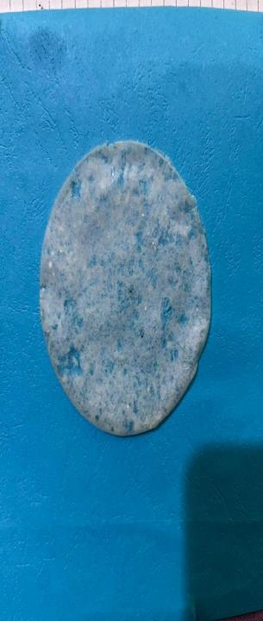 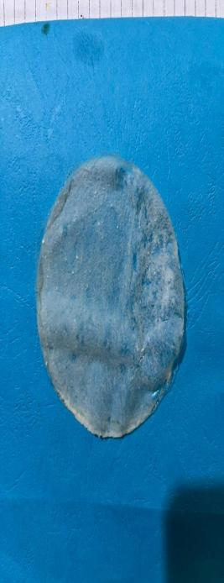 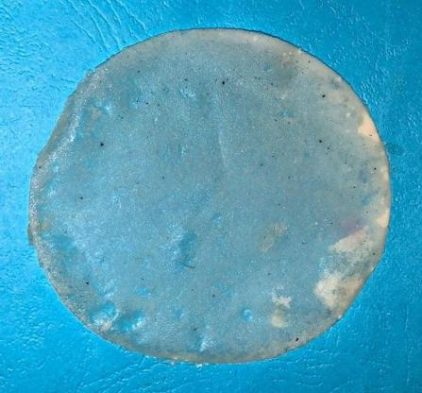

**C**

**B**

**A**

Figure 1 (A), (B) and (C): The Synthesized bioplastic

*Percentage Yield of Cellulose, Hemicellulose and Lignin*

The percentage yields of cellulose, lignin, and hemicellulose are 32.45 %, 15.85 %, and 51.7 % respectively as presented in table 1 below. Based on the obtained data, it was discovered that Hemicellulose made up a larger percentage of the cell wall.

Table 1:Percentage yield of Cellulose, Hemicellulose and Lignin

|  |  |
| --- | --- |
| SAMPLE | YIELD (%) |
| Cellulose | 32.45 |
| Lignin | 15.85 |
| Hemicellulose | 51.7 |

*Functional properties*

The functional properties of the cellulose and cellulose nanocrystal as presented in Table 2 shows the difference in particle size causes the bulk density of the celluloseand the amount of water that cellulose displaces is what causes the increased

hydrated density. Because of the cellulose’s strong binding formation, it can hold onto oil far better than water (Kristina *et al*., 2004). The hydrated density of the cellulose was greater than the packed density. The increase in crystallinity in the sample for the CNC caused an increase in bulkiness of the samples from (0.20 g/mL to 0.27 g/mL).

Table 2: Functional properties of Cellulose and Cellulose Nanocrystal

|  |  |  |  |  |  |
| --- | --- | --- | --- | --- | --- |
| SAMPLES | (g/mL) | (g/mL) | (g/mL) | (g/g) | (g/g) |
| Bulk density | Packed density | Hydrated density | WRC | ORC |
| IC | 0.31 | 0.41 | 1.0 | 0.56 | 0.43 |
| CNC | 0.42 | 0.55 | 1.25 | 0.34 | 0.39 |

IC: Isolated cellulose; CNC; Cellulose Nanocrystal; WRC: water retention capacity; ORC: Oil retention capacity.

*Cellulose Acetate degree of Substitution*

According to Rohmawati *et al.* (2018), the polysaccharide's average rate of substitution for each unit of glucose is represented by the degree of substitution (DS) value. The DS value is 3 if all of the hydroxyl groups in each unit of glucose are esterified. The cellulose ester's plastic characteristics increase with increasing DS value. Free hydroxyl groups at the C2, C3, and C6 atoms in cellulose may be changed to acetyl groups during acetylation. The greatest DS value is thus, in principle, 3. The addition-elimination process causes substitution to happen.

The reactivity of three free hydroxyl (-OH) groups varies. Due to steric restrictions, the -OH group in C6 atoms is more reactive and acetylates more quickly than -OH groups in C2 and C3 atoms. The -OH group at C2 is more reactive when compared to the -OH groups at C3 atoms. This is due to the fact that the -OH group at C2 is more acidic and closer to hemiacetal than the -OH group at C3 atoms (Rohmawati *et al.*, 2018). The value for the synthesized cellulose acetate 1.2.

*Characterisation*

*XRD Results*

The XRD graph of the extracted cellulose indicated peaks (figure 2a) at 2θ of 22.5° and 26.5° corresponding to planes {101} and {200} respectively which are characteristic peaks of cellulose of plant fibre(Thygesen*et al.*, 2005). The additional peaks shown in figure 2b, notably that of 20° indexed at {020} can be attributed to the formation of cellulose nanocrystal corresponding to that oberseved by Gong *et al.* (2017. The variable peak observed (Figures 3a-c) in thesynthesized bioplastic in the three samples are due to the different amount of glycerol used with the prevalent plane of {200} of the cellulose. The lesser crystalline peaks are due to the addition of the glycerol.

(101)

(200)

Figure 2: (a) Cellulose

Figure 2: (b)Cellulose Nanocrystal

Fig.5(a) shows the XRD graph of the cellulose having two distinct peaks showing the main crystalline regions and more amorphous regions for

the cellulose, while the result of (b) have more notable peaks at points where the amorphous regions have disintegrated to give rise to more crystalline regions.

Figure 3(a): XRD graph showing intensity peaks and the corresponding angle of synthesized bioplastic without glycerol (0ml)

Figure 3(b):XRD graph showing intensity peaks and the corresponding angle of synthesized bioplastic with glycerol (1mL)

Figure 3(c): XRD graph showing intensity peaks and the corresponding angle of synthesized bioplasticwith glycerol (2ml)

*FTIR Results*

The spectra from FTIR as shown in figure 4(a) – (c) has the following: Cellulose from Carob indicates peaks at 3295.0 cm-1 a weak, broad OH- stretching vibration, 2914.8 cm-1 C-H stretching vibrate of the alkane family and O- bending vibration in the fingerprint regions characteristic peaks at 1319.5 cm-1, 1237.5 cm-1 and 1025.0 cm-1. (b) CNC from Carob indicates two prominent peaks at 3336.0 cm-1 and 3287.5 cm-1 weak, broad OH- stretching vibration,

2896.1 cm-1 C-H stretching vibrate of the alkane family. Another notable peak is the carbonyl (C=O) peak at1640.0 cm-1. This could be attributed to the acid hydrolysis on the cellulose to reduce the amorphous region on the cellulose. (c) CNC acetate from Carob indicates peaks at 3336.0 cm-1 and 3291.2 cm-1 broad OH- stretching vibrations, 2899.9 cm-1 C-H stretching vibrate of the alkane family and carbonyl (C=O) peak at 1640.0 cm-1 subjective of the acetylation process.

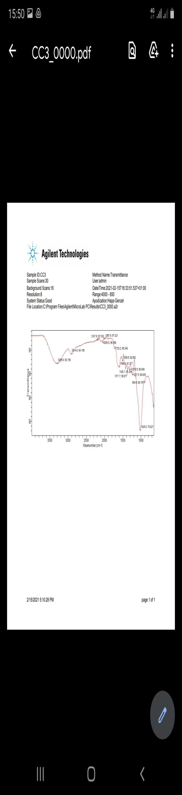

Figure 4(a): FTIR spectrumcellulose

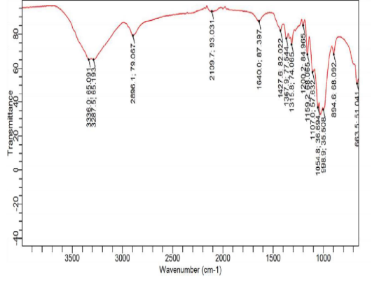

Figure 4(b): FTIR spectrum CNC

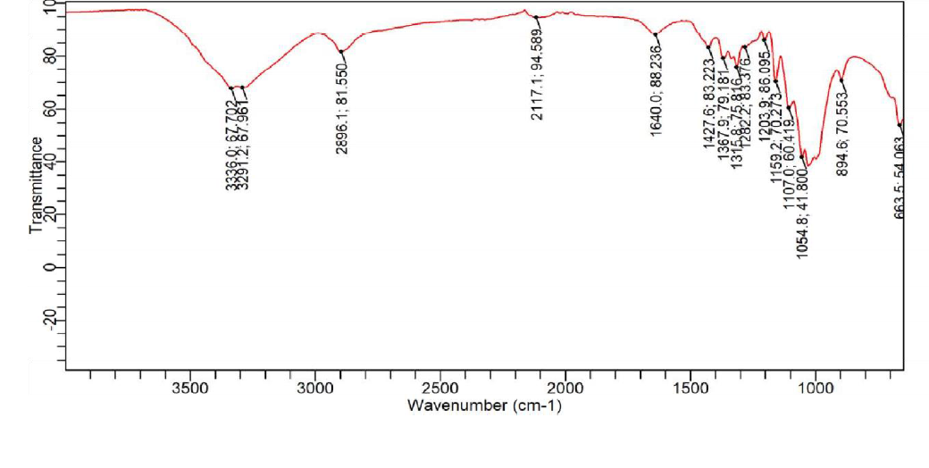Figure 4(c): FTIR spectrumCNC acetate

*SEM Micrograph*

The cellulose structures look like twisted ropes tied to each other between hydrogen liners (Figure 5 (a). These fibrils are a collection of cellulosic molecules and contained regular and less regular parts. The fibrils did not have the same diameter as that of the ordinary cellulose as more amorphous regions were removed as shown in Figure5(b). There was a notable breaking of the long fibrils in the acetate formed as evident in Figure 5 (c) showing (Rohmawati *et al.*, 2018).

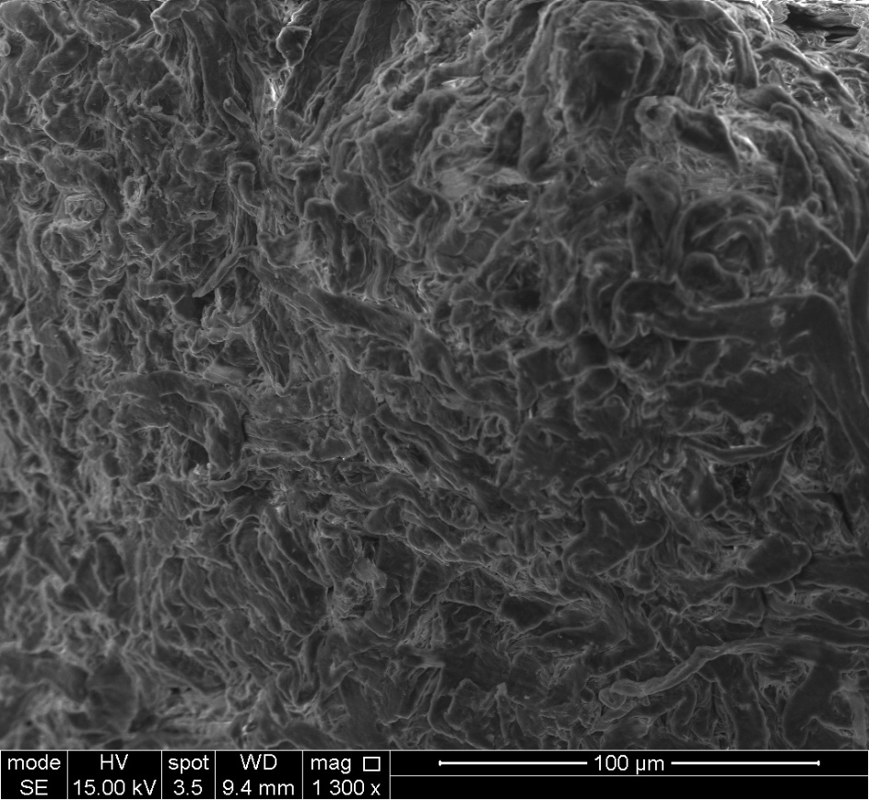

Figure5(a): SEM micrograph showing the morphology of cellulose

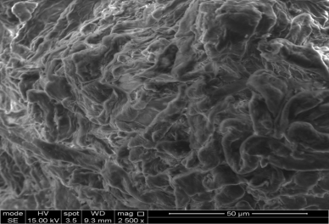

Figure 5(b): SEM micrograph showing the morphology of CNC

C:\Users\Ademola\OneDrive - sheffield.ac.uk\Desktop\Nejo\4_002.tif

Figure5 (c): SEM micrograph showing the morphologyCNC Acetate

*Degradation ability of bioplastic*

The observed results of the three masses of bioplastics before and after degradation are shown on Table 3. Bioplastic was reduced by an average mass of 72.13% after being buried in the soil-compost mixture for 28 days. This proved that bioplastics are easier to degrade than conventional plastics which were non-

biodegradable. This bioplastic was easily degraded due to the amorphous form of a polymer so that microorganisms in the soil could attack the bioplastic molecules. The pattern of degradation observed indicates the more the glycerol added the greater the degradation as more amorphous regions will be created in the sample.

Table 3: Change in Bioplastic’s Mass Before and after degradation

|  |  |  |  |
| --- | --- | --- | --- |
| Bioplastic | Initial mass | Final mass | Percentage Loss (%) |
| Sample A1 (0ml glycerol) | 0.28 | 0.12 | 57.14 |
| Sample B1 (1ml glycerol) | 0.31 | 0.07 | 77.42 |
| Sample C1 (2ml glycerol) | 0.33 | 0.06 | 81.82 |

*Mechanical properties of Bioplastic*

The bioplastic synthesized showed a progressive hardness property as the amount of glycerol used reduces as shown in Table 4. Sample A (without glycerol) has a hardness of 9.30 kgf/mm2, while Sample B (with 1ml glycerol) had an improved hardness of 10.53 kgf/mm2 and Sample C (with 2ml glycerol) further increase in hardness 11.23 kgf/mm2.

This can be attributed to the crystalline cellulose in the samples. The force of contact during the bonding of the polymeric substance decreases with increasing glycerol concentration.Glycerol may also improve bioplastics' flexibility and molecular mobility, making them more elastic and breaking-elongation-enhancing as postulated by Rohmawati *et al.* (2018)

TABLE 4: Mechanical Testing (Hardness) for Synthesized Bioplastic

|  |  |
| --- | --- |
| Bioplastic | Average Brinell Hardness (Mpa) |
| Sample A1 (0ml glycerol) | 9.30 |
| Sample B1 (1ml glycerol) | 10.53 |
| Sample C1 (2ml glycerol) | 11.23 |

The crystalline size and crystallinity index of the bioplastic synthesized indicates as shown in table 5, that Sample A is 59.8%, Sample B is 66.5%, Sample C is 70.24%. The effect of crystallinity index indicates the amount of crystal present in the sample. Most crystalline matter improves strength of the material. The result also shows the particles are within nano scale (from 4.10nm to 6.10 nm) (Abe *et al.*. 2022).

TABLE 5: (a) Crystalline size and Crystallinity index of the synthesized bioplastic

|  |  |  |  |  |
| --- | --- | --- | --- | --- |
| Bioplastic | Angle (2θ) | FWHM (degree) | Crystalline size (nm) | Crystallinity index |
| Sample A1(0ml glycerol) | 22.5 | 2.0 | 4.10 | 59.8 |
| Sample B1(1ml glycerol) | 22.4 | 1.63 | 5.53 | 66.5 |
| Sample C1 (2ml glycerol) | 22.5 | 1.42 | 6.10 | 70.24 |

The tensile strength of a materialrepresents the maximum stress/strain a material can endure without breaking during the test. The best attribute for plastic filmsis to maximize the tensile strength. This is because a greater tensile strength value means the film can survive damage from mechanical interference. There was considerable increase in this property as the amount of glycerol was increased showing a remarkable strength of 8.00 MPa as the minimum exceed the minimum value of 1.343 MPa according to the Biodegradable plastic standard by SNI 7818:2014(Gabriel *et al.*, 2021). The increase in the tensile strength of this bioplastic can be attributed to the increase in crystallinity of the

cellulose nanocrystal which was observed by Gabriel *et al.*, 2021 relating it to amylose and amylopectin content of starch in producing bioplastics observed that compared to amylopectin, which is amorphous, high amylose tends to form crystals with more considerable mechanical characteristics.

The elongation which provides information about how much a material stretches before breaking during a tensile test. Between cellulose and glycerol, there existed a hydrogen bond interaction. Furthermore, adding glycerol may make bioplastics more flexible and enhance molecular mobility, making them more elastic and capable of higher breaking elongation (Rohmawati *et al*., 2018). The increase in elongation was steady as observed from 3.70% (0mL glycerol) to 4.6% (1mL glycerol) and to 5.00% (2mL glycerol).

TABLE 6: Tensile Strength and Elongation

|  |  |  |  |
| --- | --- | --- | --- |
| Sample | Glycerol  Vol. used (ml) | Tensile strength  (MPa) | Elongation  (%) |
| A | 0 | 8.00 | 3.70 |
| B | 1 | 24.00 | 4.60 |
| C | 2 | 356.00 | 5.00 |

*Conclusion and Recommendation*

*Conclusion*

Agricultural biomass, which is abundant, can be a useful material and a sustainable one for the synthesis of bioplastic. The yield of cellulose from Carob pod shellfibre(32.45%) shows that this agro-waste can be optimized.

Acid hydrolysis, which is the process used in achieving more crystalline regions in the extracted cellulose, can be processed using a recyclable organic acid (maleic acid) rather than the conventional inorganic acid as a means of green synthesis.

Acetylation of the cellulose nanocrystal (CNC) enables the polymerization process. The crystallinity index of the bioplastic shows some interesting result which is evident in the mechanical test conducted to suggest a better strength could be achieved also.

*Recommendation*

With the intense work on reducing conventional plastic menace on man and its environment, nano-sized bioplastic could provide a viable option in this regard and also solve some problems associated with the agricultural waste disposal.

*References*

Abe, M.M,. Costa, C.S., Silva, M.C., Costa, F.S., Lima, K.V., Carvalho, L.M and Garcia, P.S. (2022). Production and assessment of the biodegradation and ecotoxicity of xylan- and starch-based bioplastics. *Chemosphere,* 287: 132 – 290.

ASTM International. (2020). ASTM D3513-20: Standard Test Method for Water Retention

(Syneresis) of Cellulose Ethers. ASTM International.

Bicu, I., and Mustata, F. (2011). Cellulose extraction from orange peel using sulfite digestion reagents. *Bioresource Technology,* 102(21): 10013–10019.

De-france, K., Hoare, T., and Cranston, E. (2017). “Nanocellulose Review". *Chemistry of material* 29(11): 4609-4631.

Feng, J., and You, L. (2015) Cellulose Nano crystal isolation from tomato peels and assembled Nano fibers. *Carbohydrate Polymers,* 122: 60-68.

Fortunati, E., Peltzer, M., Armentano, I., Torre, L., Jimenez, A., and Kenny, J. M. (2012). Effects of modified cellulose nanocrystals on the barrier and migration properties of PLA nano-biocomposites. *Carbohydrate Polymers*, 90, 948-956.

Gabriel, A., Solikhah, A. and Rahmawati, A. (2021). Tensile Strength andElongation Testing for Starch-Based Bioplastics using Melt Intercalation Method: A Review. *Journal of Physics*: Conference Series: 1, 1742-6596.

Hassan, S.S., Williams, GA, Jaiswal AK. (2018). Emerging technologies for the pretreatment of lignocellulosic biomass. *Bioresour Technol*.;262:310–318.

Huan, M. F., Yu, J. G., and Ma, X. F. (2006) High mechanical performance MMT-urea and formamide-plasticized thermoplastic cornstarch biodegradable nanocomposites. *Carbohydrate Polymers*, 63, 393–399.

ISO 6358:2009(en): Paper and Board — Determination of Oil Absorption. International Organization for Standardization.

Jiang, Z. and Ngai, T.(2022). Recent Advances in Chemically Modified Cellulose and Its Derivatives for Food Packaging Applications: A Review. *Polymers*, 14: 15-33.

Kassab, Z., Abdellaoui, Y., Salim, M. H., Bouhfid, R., Qaiss, A. E., and El Achaby, M. (2020). “Micro- and nano-celluloses derived from hemp stalks and their effect as polymer reinforcing materials”,*Carbohydrate Polymers*, 245,11 – 26.

Kibar, E. and Us, F. (2013). Thermal, mechanical and water adsorption properties of corn starch-carboxymethyl cellulose/methylcellulose biodegradable films. *Journal of Food Engineering*, 114, 123-131.

Klemm, D., Cranston, E., Fischer, D., Gama, M., Kedzior, S., Kralisch, D., Kramer, F., Kondo, T., Lindstrom, T., and Nietzsche, S. (2018). Nanocellulose as a natural source for groundbreaking applications in materials science: today’s state. Mater Today 21:720–748.

Kristina, J., Ulf, G., Djem, K., Thomas, H., and Helena L. (2004). Effect of pulp composition on the characteristics of residuals in CMC made from each pulps*. Cellulose* 12: 383-393

Lam, E, Male, K.B., Chong, J. H., Leung, A.C.W., Luong, J.H.T. (2012). Applications of functionalized and nanoparticle-modified nanocrystalline cellulose. *Trends Biotechnol*;30:283–90.

Lawal, O. S., Adebowale, K.O., Ogunsanwo, B.M., Barba, L, L, and Ilo, N. S. (2005). Oxidized and acid thinned starch derivatives of hybrid maize: functional characteristics, wide-angle X-ray diffractometry and thermal properties, *International Journal of Biological Macromolecules*,35: (2), 71-79.

Lee, K.-Y., Quero, F., Blaker, J. J., Hill, C. A. S., Eichhorn, S. J., and Bismarck, A. (2011). Surface only modification of bacterial cellulose nanofibres with organic acids. *Cellulose*, 18, 595-605.

Mohammad, A., Siti, N. H., Aliah, N., Mat N.and Mohd. S.. (2020). Development and Characterization of Food Packaging Bioplastic Film from Cocoa Pod Husk Cellulose Incorporated with Sugarcane Bagasse Fibre. *Journal of Bioresources and Bioproducts*. 5: 259-266.

Morandi, G., Heath, L., and Thielemans, W. (2009). Cellulose nanocrystals grafted with polystyrene chains through surface-initiated atom transfer radical polymerization (SI-ATRP). *Langmuir*, 25, 8280-8286.

Oksman K. (2000). Mechanical properties of natural fibre mat reinforced thermoplastic. Appl Compos Mater, 7: 403–414.

Rhim, J. W., Park, H. M., and Ha, C. S. (2013). Bio-nanocomposites for food packaging applications. *Progress in Polymer Science*, 38, 1629 – 1650.

Rohmawati B., Sya’idah F. A., Rhismayanti, Alighiri D. and Eden W. T. (2018). Synthesis of Bioplastic-based Renewable Cellulose Acetate from Teak Wood (Tectona grandis) Biowaste Using Glycerol-Chitosan Plasticizer, *Oriental Journal of Chemistry*, 34(4): 1810 – 1816.

SetaF. T., AnX., L.L., ZhangH., YangJ., ZhangW., NieS., YaoS., CaoH., XuQ., BuY., Liu H. (2020). Preparation and characterization of high yield cellulose nanocrystals (CNC) derived from ball mill pretreatment and maleic acid hydrolysis, *Carbohydrate Polymers*, 234: 1 – 10.

Song, J., and Rojas, O. J. (2013). Paper chemistry: Approaching super-hydrophobicity from cellulosic materials: A review. *Nordic Pulp and Paper Research Journal*, 28(2), 216–238.

Thygesen, A., Oddershede, J., Lilholt, H., Thomsen, A.B. and Stahl, K. (2005). On the determination of crystallinity and cellulose content in plant fibres. *Cellulose*, 12: 563-576.